**HISTORIC 170 CARAT PINK DIAMOND RECOVERED AT LULO MINE**

The ENDIAMA, Lucapa Diamond and Rosas & Petalas , Lulo Diamond Company partners, are proud to announce the recovery of an historic 170 carat pink Type IIa diamond from the Lulo alluvial mine.

The 170 carat pink stone is an historic recovery as it is believed to be the largest pink diamond recovered in the last three hundred years. The diamond has been given the name “The Lulo Rose”.

The Lulo concession boasts the two largest recorded diamonds recovered in Angola, the largest being the 404 carat “4th February Stone”. This historical pink diamond is the 5th largest diamond and is the 27th +100 carat recovered to date on the Lulo concession.

According to the Marketing Diamond Policy, the diamond will be sold soon in an auction organized by SODIAM.

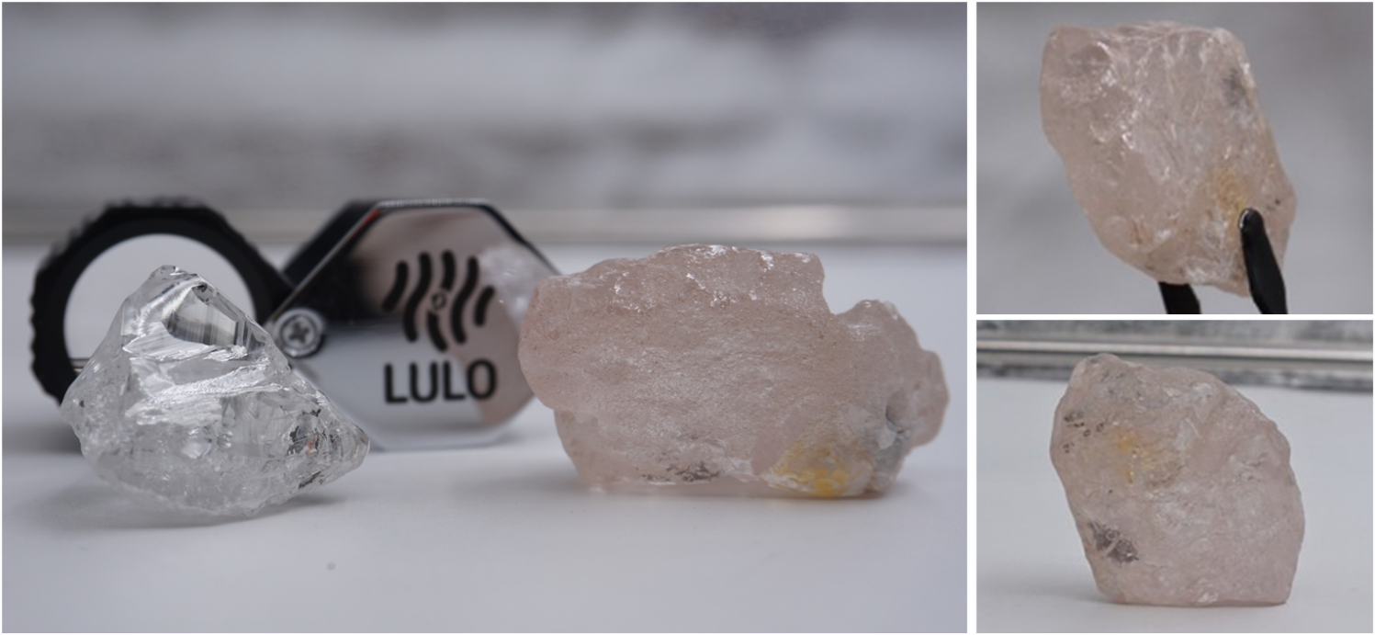

*Photos: Historic 170 carat pink diamond recovered from Lulo, Angola (80 carat white in main picture)*

His Excellency Diamantino Azevedo, Angola’s Minister of Mineral Resources, Petroleum and Gas said, “This record and spectacular pink diamond recovered from Lulo continues to showcase Angola as an important player on the world stage for diamond mining and demonstrates the potential and rewards for commitment and investment in our growing diamond mining industry.”

Dr JoséManuel Augusto Ganga Júnior, Chairman of the Board of ENDIAMA commented, “The record-breaking Lulo diamond field has again delivered a precious and large gemstone, this time an extremely rare and beautiful pink diamond. It is a significant day for the Angolan diamond industry, particularly for the Lulo Mining Company a long-standing partnership between ENDIAMA, Lucapa Diamond and Rosas and Petalas.”

Lucapa Diamond Company Limited Managing Director, Stephen Wetherall said “Lulo is an exceptional alluvial resource and is truly a gift. We are once again made very proud by yet another historic recovery. We too look forward to our partnership progressing its exploration effort, where we are now bulk sampling the priority kimberlites, in search for the primary kimberlite sources of these exceptional and high-value diamonds.”

-End-

*Photo collage 1*

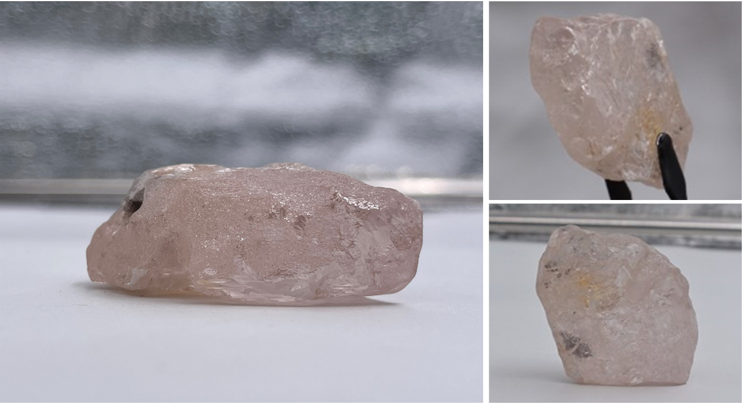

*Photo collage 2*



*Photo collage 3*

